MEDICAL APPOINTMENT SYSTEM
By Namrata Doddamani
- Intent
The “Medical Appointment System (MAS) “project is a model appointment booking
interface. This interface enables the user to book an appointment with the doctor they
want by just registering. MAB provides an easier method for a person sitting anywhere to book an appointment with the concerned doctor in any hospital. The primary aim of this MAS is to provide an improved design methodology, which envisages the future expansion, and modification, which is necessary for a core sector like the health sector. This necessitates the design to be expandable and modifiable and so a modular approach is used in developing the application interface. Now a day’s standing in a line to book an appointment for a health issue is tedious job up to certain limit. So, a software that reduces the work is essential. Also, today’s world is a genuine computer world and is getting faster and faster day-by-day.
Thus, considering above necessities, the software for medical appointment system is necessary to avoid the long lines and the time waste. The software is meant to overcome the drawbacks of the manual system. The graphical user interface has been developed using a powerful java application that is, NETBEANS IDE 8.2 and secure backend MYSQL database and the most widely accepted as well as application oriented.

2. Output
The below On running the application the Main Page is displayed:
FIGURE 1: Main Page

When USER LOGIN button is clicked:
FIGURE 2: User login
When the NEW USER CLICK HERE button is clicked the below frame is displayed:
FIGURE 3: New user

On entering details if the password is less than 6 characters the trigger displays the trigger exception message in JOptionPane Dialog Window:
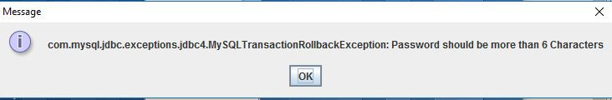
FIGURE 4: Password Trigger Error message

If the Password and all details are entered correctly you will be redirected to login page:
FIGURE 5: Login page with wrong password

If the password entered is wrong Invalid message is displayed in JOptionPane Dialog Window:
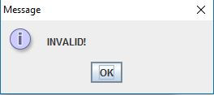
FIGURE 6: Invalid password error message

If the details are Entered correctly the belowe frame is displayed:
FIGURE 7: Main Appointment Page

When BOOK AN APPOINTMENT button is clicked the below frame is displayed:
FIGURE 8: Doctor Fields

When a Radio Button is selected and CONTINUE button is clicked below frame is displayed:
FIGURE 9: Doctor selection

On selecting a DocId from the ComboBox and clicking Proceed Button the next frame is displayed
FIGURE 10: Select Appointment Timing

If we chose a date that already passed the current date the trigger is activated and the trigger error message is displayed in a JOptionPane :
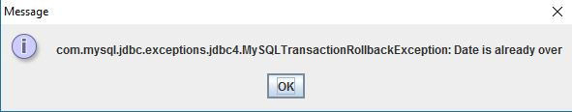
FIGURE 11: Trigger Message for Invalid Date

If the time and date for the appointment for that doctor is already booked by someone else the trigger is activated and the trigger error message is displayed in JOptionPane:
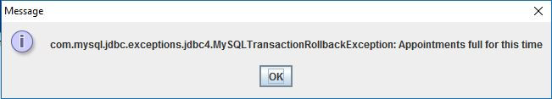
FIGURE 12: Trigger Message for Appointment Full

If the time and date are correct and available the next frame is displayed with all the details of the appointment:
FIGURE 13: Appointment Details
On clicking Cancel button the current entry will be deleted from database and it will
go back to FIGURE 12

On clicking Confirm the entry will kept in database and the below frame will be
displayed:
FIGURE 14: Confirmed

If the View All Appointment button is clicked the below frame is displayed
FIGURE 15: View all appointments

If we click ADMIN LOGIN button in FIGURE 5.1 we get the below frame:
FIGURE 16: Admin Login

If the correct details are entered and Submit button is clicked, we get the below frame:
FIGURE 17: Admin choice

If Delete Todays Appointment is clicked, we get the below frame
FIGURE 18: Delete appointment

On clicking the delete button the JOptionPane Dialog window displays the following message:
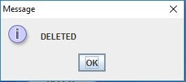
FIGURE 19: Deleted Message

3.Conclusion
This project is all about making a meeting with a doctor a very simple process. A suitable Java functions and methods are used to develop objects. The aim of this project is to reduce the burden of going to a hospital and waiting for long time intervals in the line to book an appointment. A database which contains all the doctors of a particular health field was created. The people can now easily register with us and book an appointment. If the particular doctor is not available for a given time slot, triggers have been used to let the person make an appointment for the next available slot. In this way this project makes an effort to create a medical appointment for a health issue using a computer.
4. Future Enhancement
The future enhancement of the project will include:
- Allowing the users to delete appointments they had already made with the particular doctor.
- Allowing admins to view all details of users and delete user.
- Allowing admins to add new doctors and remove them.

